Name: Andrew Virya Victorio

NIM: 32200091

Class: 2PTI1

Picture:

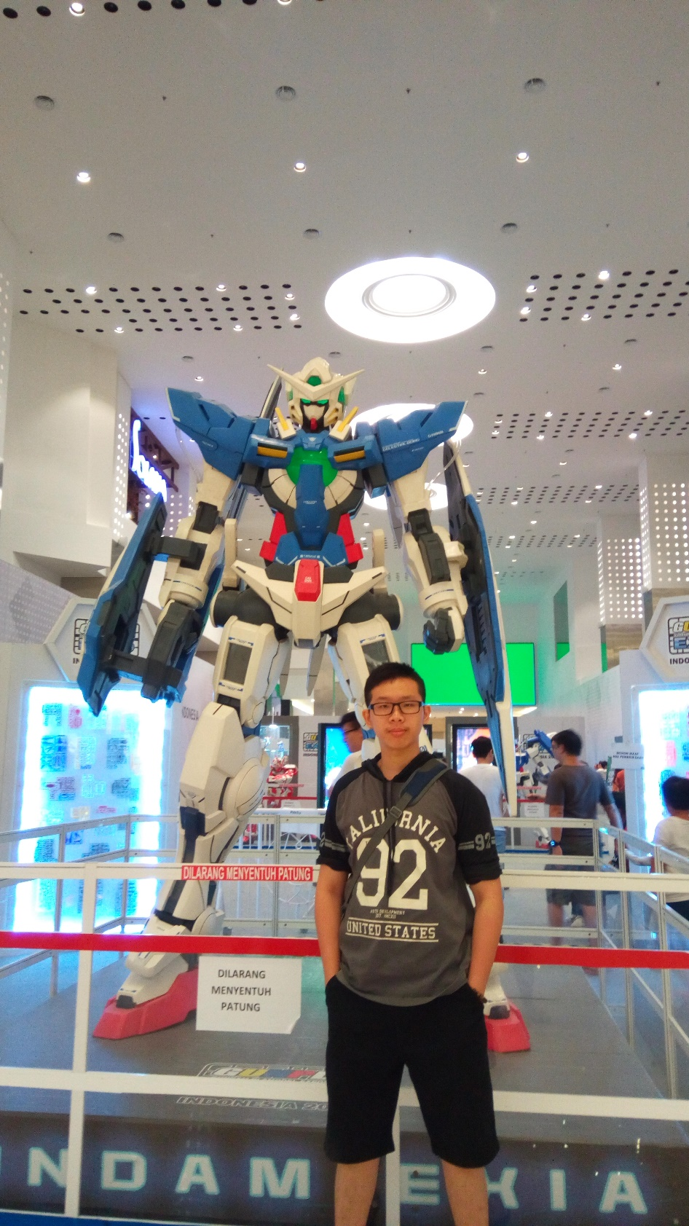

Hello Miss Swanny. My name is Andrew Virya Victorio from 2PTI1 class. So, I decide to take a photo with that robot. The photo was taken at Mall of Indonesia by my friends. I like that photo because I have interest in robotic figure. The robot is called Gundam. A robotic anime series in Japan. Also, I really like Gundam, I like to assemble the Gundam figure because that is the fun part when you buy a Gundam figure. I already own five Gundam at home.